### 



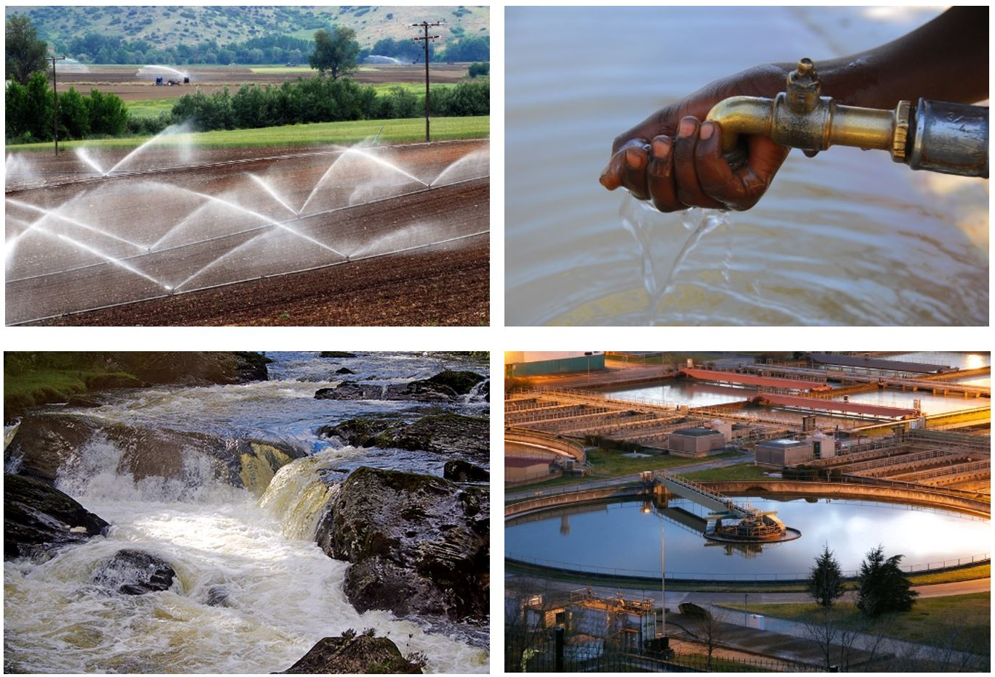

**Methodology for Water quantification in Drip Irrigation Practices**

***Beta***

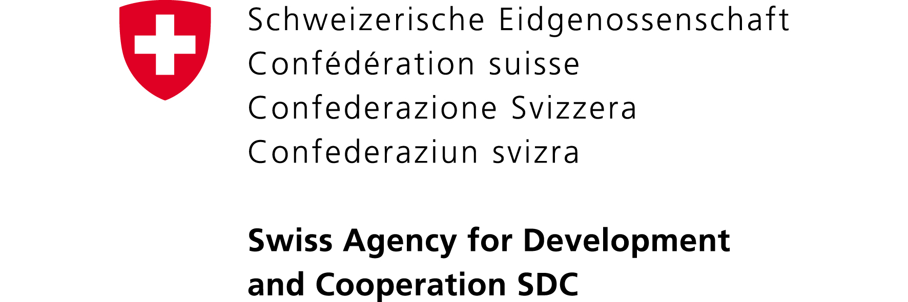

Contents

1. Definitions & Applicability 2

1.1 Definitions 2

1.2 Applicability Criteria 4

1.3 Introduction to Drip Irrigation 4

1.4 Ownership of the Water Benefits 5

2 Calculation of Water Benefits 6

2.1 Water Volume Quantification Concept 6

2.2 Steps to Calculate Water Benefits 6

2.3 Monitoring Approach 7

3 Data Collection 9

3.1 Project Boundary 9

3.2 Primary Variables 9

4 Water Quality 15

5 Guidance to Quantify Water 15

6 Sustainability 17

6.1 Return Flow Assessment 17

### 

### Definitions & Applicability

### 1.1 Definitions

* ***Water Withdrawal*** *–* The volume of freshwater abstraction from surface or groundwater for an intended purpose. Withdrawal is directly measurable as the quantity of water withdrawn from the source for a particular activity over a specific period of time.
* ***Water Consumption*** *–* The volume of withdrawn water that is evaporated or transpired for an intended purpose.
* ***Drip Irrigation*** *–* Drip irrigation is sometimes called trickle irrigation and involves dripping water onto the soil at very low rates (2-20 litres/hour) from a system of small diameter plastic pipes fitted with outlets called emitters or drippers. Water is applied close to plants so that only part of the soil in which the roots grow is wetted (Figure 60), unlike surface and sprinkler irrigation, which involves wetting the whole soil profile. With drip irrigation water, applications are more frequent (usually every 1-3 days) than with other methods and this provides a very favourable high moisture level in the soil in which plants can flourish.[1]
* ***Flood Irrigation*** *–* A group of application techniques involving distribution of water in a field by the gravity flow of water over the soil surface. The soil acts as the medium in which the water is stored and the conveyance medium over which water flows as it spreads and infiltrates. Flood irrigation is characterized by uncontrolled distribution of water.
* ***Crop Yield*** *–* Weight of economically valuable crop that is harvested per unit of harvested area.
* ***Baseline Activity*** *–* Adoption of traditional irrigation practices that are relatively inefficient with water use. Traditional irrigation methods such as flood irrigation typically use gravity to disperse water across the field.
* ***Project Activity*** *–* Implementation of irrigation practices that promote higher irrigation efficiency, thereby reducing water withdrawal volume.
* ***Sprinkler Irrigation*** *–*A method of applying irrigation water which is similar to natural rainfall. Water is distributed through a system of pipes usually by pumping. It is then sprayed into the air through sprinklers so that it breaks up into small water drops before falling to the ground. The pump supply system, sprinklers and operating conditions are typically designed to enable a uniform application of water.[2]
* ***Basin Hydrological Flow*** *–* The characteristic behaviour and total quantity of water involved in a drainage basin. This is determined by measuring such quantities as rainfall, surface and subsurface storage and flow, and evapotranspiration and the impact of project interventions on these factors.
* ***Return Flow*** *–*Quantities of water that are returned to the sources from which they were withdrawn to be made available for other purposes or users (e.g. downstream farmers or wildlife). This could include unused water withdrawn for agricultural purposes that is returned to surface water sources or recharges groundwater aquifers.
* ***Blue water footprint*** *–* Volume of surface and groundwater consumed as a result of the production of a good or service. Consumption refers to the volume of freshwater used and then evaporated/transpired or incorporated into a product. It also includes water abstracted from surface or groundwater in a catchment and returned to another catchment or the sea. It is the amount of water abstracted from groundwater or surface water that does not return to the catchment from which it was withdrawn.[3]
* ***Green water footprint*** *–* Volume of rainwater consumed during the production process. This refers to the total rainwater evapotranspiration (from fields and plantations) plus the water incorporated into the harvested crop.[4]

### 1.2 Applicability Criteria

This methodology quantifies water conserved as a result of the implementation of drip water irrigation practices. The following conditions reflect the applicability of the water benefit methodology to project activities.

* The methodological framework can be applied to any intervention that replaces prevailing, less efficient and more water consuming irrigation practices with more efficient irrigation practices (e.g., conversion from flood to sprinkler irrigation or from sprinkler to drip irrigation).
* The methodology applies to single farms or bundled farms within the same representative spatial boundary.
* This methodology applies to cultivation that makes use of groundwater and surface water resources for irrigation, using pumped or gravity systems for the baseline and/or project activities. Projects that rely only on rainwater for watering crops are not eligible.
* For all irrigation interventions regardless of water source, an appropriate environmental impact assessment must be undertaken analysing the return flow composition of each individual source and the associated dependent ecosystems (see Section 6).
* This methodology requires a baseline scenario in which farmers involved in the project have not already made use of the drip irrigation techniques described in Section 2. This means that farmers installing and using the new irrigation system, and thus counted as beneficiaries, must confirm that they cultivated their land according to conventional irrigation practices prior to the project activity as indicated in the baseline description (this may be done as part of the Local Stakeholder Consultation).
* This methodology cannot be used to quantify other water-efficient agricultural practices (e.g. water retention basins, micro catchments, waste water treatment, nursery for water efficient plants, etc.). Such techniques can be found in their respective intervention-specific methodologies.
* Only water conserved by the project activity will be taken into account in the water benefit calculation. Any additional positive social impacts, while encouraged, will not be quantified for the purpose of calculating WBCs.
* This methodology applies to land that is already under cultivation in the baseline scenario. Previously abandoned or marginal land that was not under cultivation in the baseline scenario may not be included in the project activity except in cases where the total agricultural water supply has been sustainably increased as determined by other WBS methodologies (see methodologies regarding Groundwater Recharge interventions and Water Retention Basins). In such cases, the project developer must demonstrate that any re-cultivation of abandoned land is sustainable within the bounds of existing water resources and water availability for downstream users. These considerations must be addressed as part of the assessment in Section 6.

### 1.3 Introduction to Drip Irrigation

Inefficient irrigation practices contribute to a great deal of wastage of agricultural inputs including overdrawing on the amount of water required to grow crops and an over application and indiscriminate use of fertilizers. Sprinkler irrigation technology can save up to 50% of the necessary irrigation water volume needed for local food crop production compared to traditional flood irrigation practices, and drip irrigation can save up to 80%. If applied in a sustainable context, water-efficient irrigation techniques can improve the resilience of the local food crop production as less water is needed for the same agricultural outcome. This can lessen pressure on blue water[5] sources and thus allow for the cultivation of more crops.

Furthermore, the drip irrigation method saves water and fertilizer by allowing water to drip slowly to the roots of plants, either onto the soil surface or directly into the root zone through a network of valves, pipes, narrow tubing and emitters that deliver water directly to the base of the plant. In addition, we encourage the use of complementary technology to enhance the efficiency of the drip irrigation intervention, such as moisture sensors buried in the soil that help optimize the application of water to crops.

An example of a drip irrigation system layout and its different components are sketched out below in Figure 1.

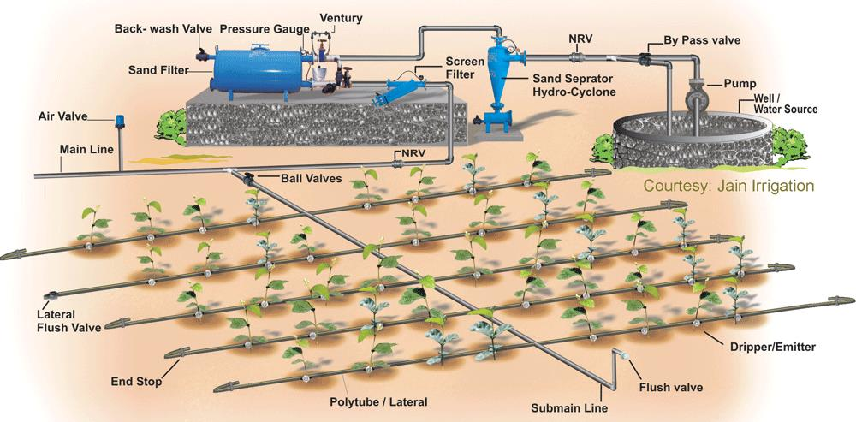

*Figure 1: The Drip irrigation system layout and its different components.*

### 1.4 Ownership of the Water Benefits

The ownership of the WBCs lies with the farmers, who actively achieve the water conservation by purchasing and using the drip irrigation technology. If the water savings occur on-site in a production facility, the ownership will lie with the owner of this facility.

This ownership can be transferred to the project developer (international enterprise or organization) in a credible way (e.g. during Local Stakeholder Consultation as a condition for participation in the project).

### 2 Calculation of Water Benefits

### 2.1 Water Volume Quantification Concept

Two metrics that are generally applied to quantify water volume relevant to agriculture activities are water withdrawal and water consumption. For the calculation of WBCs, this methodology is based on the concept of water consumption. The water consumption approach was selected as it accurately reflects the total water savings resulting from the intervention by taking into account return flows and water lost from the watershed.

The calculation of water benefits involves accounting for differences in water savings and yield achievable under baseline and project activities. Rather than calculating absolute water savings, this methodology accounts for the amount of water saved with drip irrigation to achieve the same amount of crop yield with traditional irrigation.

Concerns over broader water sustainability on a watershed-wide level based on consumption metrics are addressed in Section 6.

### 2.2 Steps to Calculate Water Benefits

**Step 1: Quantify water flows and yield under baseline and project conditions**

**Baseline Condition**

* Total irrigation under the baseline activity (WIB) over the entire growing season of the crop in m3/hectare
* Return flow (WBRF) under the baseline activity over the entire growing season of the crop in m3/hectare.
* Crop yield achieved under baseline activity (YB), tonnes/hectare

**Project Condition**

* Total irrigation under the project activity (WIP) over the entire growing season of the crop in m3/hectare
* Return flow (WPRF) under the project activity over the entire growing season of the crop in m3/hectare.
* Crop yield achieved under project activity (YP), tonnes/hectare

**Step 2: Calculate the blue water requirement for the baseline and project scenarios respectively**

*WB = WIB - WBRF*

*WP = WIP - WPRF*

*Where:*

*WB is the total blue water required per crop in the baseline in m3/hectare*

*WP is the total blue water required per crop in the project activity in m3/hectare*

**Step 3: Calculate water consumption required under project activity to achieve baseline yield**

*WP,YB = (YB / YP) x WP*

*Where:*

*WP,YB is the estimated water consumption* *with project activity (WP) to produce yield achieved under baseline activity (YB), m3/hectare*

**Step 4: Calculate the difference in water consumption between baseline activity and project activity (calculated under step 2)**

*(delta)W = (WB) - (WP,YB)*

*Where:*

*(delta)W is the water savings, based on the difference in water consumption between baseline activity and project activity to achieve the baseline yield,* *m3/hectare*

**Step 5: Estimate water benefit resulting from project activity**

*Q = (delta)W x AP*

*Where:*

*Q is the quantity of water benefit resulting from project activity for specific crop, m3*

*AP is the crop production area affected by the project activity, hectares*

**Step 6: Estimate water benefit resulting from project activity for all crops**

Steps 1 through 4 involve calculation of water benefits by crop type. The total water benefits for all crops affected by the project activity can be estimated as follows:

QTot = Q1 + Q2 + Q3 + ... ... ... + QN

*Where:*

*N is the number of crop types affected by project activity*

*QTot is the total quantity of water benefits for all crops affected by the project activity, m3*

### 2.3 Monitoring Approach

Baseline Scenario

* Project participants may determine the baseline parameters including WB (m3/ha), WBRF (m3/ha) and YB (tonnes/ha) for different crops based on precise field measurements on a sample basis conducted using scientifically approved international or national methodologies.[6] Alternatively, baseline parameters based on eligible data[7] may be used to determine conservative baseline factors. Baseline factors derived from data do not require supplementary field measurements; however these factors must be conservative. Where possible, a range of viable baseline factors from source literature should be presented to demonstrate conservatism within the baseline calculations above.
* The baseline parameters shall be fixed for the duration of the crediting period and must be representative of an average year of precipitation. In the case of renewable projects, the baseline must be re-evaluated and justified during each 7-year renewal.
* If the project involves the cultivation of previously abandoned land, baseline factors may be determined from either eligible published data or from field measurements taken from existing cultivated land within the project boundary. In the case of field measurements, average figures determined from existing cultivated land may be used. In the case of published data, the figures must be representative of the geographical region, agro-climatic zone and cultivated crop, and must be deemed eligible by The Gold Standard.

Project Monitoring

* Approach I: Project participants shall conduct monitoring for each crop type using sampling to demonstrate project activities. Monitoring shall include WP (m3/ha), WPRF (m3/ha), YP (tonnes/ha) and AP (ha).
* Approach II: The following monitoring approach can be followed in cases where monitoring by individual crop type is not feasible. Project participants can group crops of similar type into different categories. A single crop can be selected as the representative crop for each category and the representative crops shall be monitored. Project participants shall determine crop categories based on duration of cultivation. An example crop categorization may group crops grown for 2 – 6 months, 6 – 12 months and > 12 months. Project participants shall determine water savings (delta) W (litres/acre) parameters for different crops based on field measurements or a literature review. The crop with average (delta) W shall be selected as the representative crop for that category and monitored during project activity. Either the entire population of fields or a sample of fields under representative crops can be monitored. Monitoring shall include WP (m3/ha), WPRF (m3/ha), YP (tonnes/ha) and AP (ha).
* If the project involves the cultivation of previously abandoned land, any water required to work the soil into an appropriate medium suitable for cultivation, or that requires any other form of pre-irrigation to prepare the soil, must be taken into account as water withdrawn under the project scenario. Project that do not require such pre-irrigation must justify the reason in the monitoring report.

### 3 Data Collection

### 3.1 Project Boundary

Data collection relevant to project activities shall be conducted within a representative spatial boundary. A representative spatial boundary is defined as the geographic unit within which rainfall pattern, cropping pattern, irrigation pattern and soil characteristics can be considered similar. Examples of an appropriate representative boundary include agro-climate regions, watersheds or defined administrative boundaries such as provinces or districts.

### 3.2 Primary Variables

The variables discussed below are primary baseline variables required for the calculation of water benefits. Once established, these variables shall be fixed for the duration of the project period. In the case of renewed projects, the baseline must be re-evaluated and justified during each 7 year renewal:

|  |  |
| --- | --- |
| *Data/Parameter:* | WIB |
| *Data Unit:* | Cubic Metres per Hectare |
| *Description:* | Total irrigation under the baseline activity over the entire growing season of the crop. |
| *Source of Data:* | On-site measurements or eligible published data as described in Section 2.3 that reference the relevant crop and agro-climatic zone respectively. |
| *Measurement Procedures* | For on-site measurements, see Section 5: Guidance to Quantify Water. For projects using published studies, data must be deemed eligible by The Gold Standard. |
| *Monitoring Frequency:* | Monthly and aggregated over the entire growing season. Factors derived from eligible published data as described in 2.3 must be selected only once. |
| *QA/QC Procedures:* | Meters on water lines will be properly calibrated and checked for accuracy using the following criteria;   * Sampling ( 90/10 confidence interval) of flow meters to assess accuracy on  seasonal basis[8] * The accuracy of the meter must be within the tolerance of the technology as defined by the manufacture or demonstrated intervention. * If after 2 years, accuracy measurements have successfully been recorded consecutively, the frequency may be reduced to annual measurement. * Where accuracy tests fail, meters must be recalibrated in accordance with manufacturer guidelines or appropriate to the technological intervention   In the event the water flow meter is not in service as a result of maintenance, repairs or testing, the indirect measurements will be taken following guidance in Section 5. |

|  |  |
| --- | --- |
| *Data/Parameter:* | WBRF |
| *Data Unit:* | Cubic Metres per Hectare |
| *Description:* | Flow of applied irrigation water that returns to the source of withdrawal or recharges groundwater under the baseline activity over the entire growing season of the crop. |
| *Source of Data:* | The CROPWAT online tool or eligible published data. |
| *Measurement Procedures* | Return-flows may be calculated by subtracting water lost from the watershed as a result of the project (e.g. through crop evapo-transpiration) from WIB as indicated by the equation below:  *WBRF = WIB - WLB*  *Where:*  *WLB = Water lost to the watershed through crop evapo-transpiration and surface evaporation as a result of applied water in the baseline*  Such losses may be calculated using CROPWAT. CROPWAT allows the project developer to determine the evapo-transpiration requirements of the plants and surface evaporation of applied water. These water volumes can be determined by inserting variables into the tool from known parameters including the relevant soil type and climate zone of the farmland, the schedule and volume of water application and crops grown.  It is important that the irrigation schedule and volumes submitted to CROPWAT matches the requirements of the irrigation technique being measured (e.g. infrequent water applications with a higher volume of water in the case of flood irrigation, and frequent applications with a lower volume of water in the case of drip or sprinkler irrigation).  Once determined, any water used through the evapo-transpiration requirements of the crops or lost as surface evaporation must be subtracted from WIB.  The remaining water volume may be counted as return flow WBRF, which is flow returned to the soil as infiltration beyond the crop root zone and/or flows into drains.  In the case of published data, studies must make reference to the relevant region, crop and agro-climatic zone, and must receive approval from the Gold Standard. |
| *Monitoring Frequency:* | Established once and fixed. |
| *QA/QC Procedures:* | No QA/QC procedures are required. |

|  |  |
| --- | --- |
| *Data/Parameter:* | YB |
| *Data Unit:* | Tonnes per Hectare |
| *Description:* | Crop yield (mass of crop harvested) achieved under the baseline activity per unit of land area over the entire growing season of the crop. |
| *Source of Data:* | On-site measurements, response to market questionnaire by the farmer or eligible published data as described in Section 2.3 that reference the relevant crop and agro-climatic zone respectively. |
| *Measurement Procedures* | Crop yield can be obtained from harvesting the entire field and weighing the crop. Yield can also be estimated by marking a small area of the field and harvesting and weighing the crop within the selected area. Yield should then be converted to units of yield per acre. Alternatively, yield can also be obtained via questionnaires to farmers by obtaining marketed harvest and area of cultivation.  Alternatively, factors derived from eligible published data as described in 2.3 must be selected only once. |
| *Monitoring Frequency:* | Once at the end of each growing season. |
| *QA/QC Procedures:* | No QA/QC procedures are required. |

The variables listed below are relevant to project activities and must be monitored during the crediting period as indicated:

|  |  |
| --- | --- |
| *Data/Parameter:* | WIP |
| *Data Unit:* | Cubic Metres per Hectare |
| *Description:* | Total irrigation under the project activity over the entire growing season of the crop. |
| *Source of Data:* | On-site measurements. |
| *Measurement Procedures* | For on-site measurements, see Section 5: Guidance to Quantify Water. |
| *Monitoring Frequency:* | Monthly and aggregated over the entire growing season. |
| *QA/QC Procedures:* | Meters on water lines will be properly calibrated and checked for accuracy using the following criteria;   * Sampling ( 90/10 confidence interval) of flow meters to assess accuracy on  seasonal basis[9] * The accuracy of the meter must be within the tolerance of the technology as defined by the manufacture or demonstrated intervention. * If after 2 years, accuracy measurements have successfully been recorded consecutively, the frequency may be reduced to annual measurement. * Where accuracy tests fail, meters must be recalibrated in accordance with manufacturer guidelines or appropriate to the technological intervention   In the event the water flow meter is not in service as a result of maintenance, repairs or testing, the indirect measurements will be taken following guidance in Section 5. |

|  |  |
| --- | --- |
| *Data/Parameter:* | WPRF |
| *Data Unit:* | Cubic Metres per Hectare |
| *Description:* | Flow of applied irrigation water that returns to the source of withdrawal or recharges groundwater under the project activity over the entire growing season of the crop. |
| *Source of Data:* | The CROPWAT online tool. |
| *Measurement Procedures* | Return-flows may be calculated by subtracting water lost from the watershed as a result of the project (e.g. through crop evapo-transpiration) from WIP as indicated by the equation below:  *WPRF = WIP - WLP*  *Where:*  *WLP = Water lost to the watershed through crop evapo-transpiration and surface evaporation as a result of applied water from the project*  Such losses may be calculated using CROPWAT. CROPWAT allows the project developer to determine the evapo-transpiration requirements of the plants and surface evaporation of applied water. These water volumes can be determined by inserting variables into the tool from known parameters including the relevant soil type and climate zone of the farmland, the schedule and volume of water application and crops grown.  It is important that the irrigation schedule and volumes submitted to CROPWAT matches the requirements of the irrigation technique being measured (e.g. infrequent water applications with a higher volume of water in the case of flood irrigation, and frequent applications with a lower volume of water in the case of drip or sprinkler irrigation).  Once determined, any water used through the evapo-transpiration requirements of the crops or lost as surface evaporation must be subtracted from WIP.  The remaining water volume may be counted as return flow WPRF, which is flow returned to the soil as infiltration beyond the crop root zone and/or flows into drains. |
| *Monitoring Frequency:* | Established once per growing season based on the irrigation schedule used in that season. |
| *QA/QC Procedures:* | No QA/QC procedures are required. |

|  |  |
| --- | --- |
| *Data/Parameter:* | YP |
| *Data Unit:* | Tonnes per Hectare |
| *Description:* | Crop yield (mass of crop harvested) achieved under the project activity per unit of land area over the entire growing season of the crop. |
| *Source of Data:* | On-site measurements or response to market questionnaire by the farmer. |
| *Measurement Procedures* | Crop yield can be obtained from harvesting the entire field and weighing the crop. Yield can also be estimated by marking a small area of the field and harvesting and weighing the crop within the selected area. Yield should then be converted to units of yield per acre. Alternatively, yield can also be obtained via questionnaires to farmers by obtaining marketed harvest and area of cultivation. |
| *Monitoring Frequency:* | Once at the end of each growing season. |
| *QA/QC Procedures:* | No QA/QC procedures are required. |

|  |  |
| --- | --- |
| *Data/Parameter:* | AP |
| *Data Unit:* | Hectare |
| *Description:* | Area of crop production affected by project activity |
| *Source of Data:* | Precise data must be obtained using global positioning technology such as handheld GPS devices, Google Earth’s path/ruler tool (earth.google.com) or other similar tools. |
| *Measurement Procedures* | Using an individual survey of the farm plot using a handheld GPS device, the path/ruler tool in Google Earth based on a known farm address or other precise global mapping approaches, the number of hectares involved in the project activity must be identified based on their coordinates and quantified for each cultivated farm.  A sum figure is taken of all hectares under cultivation to arrive at the total hectares affected by the project activity. |
| *Monitoring Frequency:* | Once per growing season. |
| *QA/QC Procedures:* | No QA/QC procedures are required. |

### 4 Water Quality

No water quality requirements or restrictions are applicable at this time for the implementation of project activities which use this methodology beyond those outlined in the sustainability section of the requirements document.

### 5 Guidance to Quantify Water

If field measurements are used to determine baseline and project activity factors, the following techniques must be used for quantifying water volumes. Two alternative options are recommended for measuring water withdrawn for groundwater irrigation. The order of preference reflects the accuracy and increasing uncertainty associated with each methodology.

Direct measurement of water withdrawn using water meter (preferred)

Metering data should provide an estimate of the cumulative volume of water withdrawn over a specific period of time (a month or an entire year).

1. Determine the pump capacity per hour for the used pump. From this it is possible to calculate the total volume of water withdrawn by multiplying the capacity by the total number of pumping hours. The total pumping hours can be derived from either Options I, II or III below.
2. Option I – If the project pump-set uses electricity metering, record the annual kWh consumption and divide by the project pump-set power demand or electricity consumption rate, as determined based on the performance curve and the head. Annual electricity consumption of project pump-sets can also be determined on a sample basis.[10]
3. Option II – Based on direct measurement through installed hour meters (or alternate arrangements like current sensor with data logger, etc.) at each project pump-set or a representative sample of all metered pumps to measure the number of hours of operation.
4. Option III - Obtain hours of operation based on maintaining a log of total pumping hours on the farm site (e.g. logging the time that the pump was turned on and off) and aggregating the hours at the end of each growing season. Total water withdrawn can then be calculated by dividing the total pumping hours by the known pump capacity or indirect capacity as determined by the time fill approach.

The volume of water withdrawn, in m3, should be divided by the area under crop production to obtain water withdrawal in units of m3/hectare.

Indirect measurements of water withdrawn

If it is not possible to use installed meters, but the pump capacity is known and documented, the water withdrawn may be determined by logging the total pumping hours required to cultivate the crop as described below:

The record of cumulative operating hours of project pump set (time) throughout the growing season is required to determine the total water withdrawal volumes. Either of the following approaches can be used to calculate the operating hours of the project pump-set.

1. Obtain hours of operation based on direct measurement through metering electricity usage at each project pump-set.
2. Obtain hours of operation based on maintaining a log of total pumping hours on the farm site and aggregating the hours at the end of each growing season. Total water withdrawn can then be calculated by dividing the total pumping hours by the known pump capacity or indirect capacity as determined by the time fill approach.

However, where pump capacity is not known, project proponents may use the Time Fill method. The Time Fill method is an alternative approach to estimate volume of water withdrawal. This approach relies on estimating flow by measuring the period of time it takes to fill a container of known volume, and is appropriate when metering pump activity is not possible or financially feasible. This must be justified by the project proponent. More details on this approach are provided by the Food and Agricultural Organization (FAO, 1993).[11] The following procedures can be applied to measure water withdrawal for drip irrigation:

The rate of water discharge can be measured either directly at the outlet of the pump or at the outlet of the drippers.

The following procedure can be applied to measure water discharge at the pump outlet.

1. Place the container of known volume directly under the pipe. All of the discharge should flow into the container.
2. Using a stop-watch, record the time it takes to fill the container.
3. Repeat the process 5 times to obtain the average rate of discharge (in volume/time).
4. Repeat monitoring of discharge at regular intervals throughout the year.

All volumes of water withdrawn, in m3, should be divided by the area under crop production per growing season to obtain water withdrawal for the project activity in units of m3/hectare.

### 6 Sustainability

### 6.1 Return Flow Assessment

Return Flow Composition

A major concern of any agricultural intervention that alters the rate of water withdrawal from surface or groundwater sources is the extent to which this intervention alters the return flow composition within a catchment and the resulting impact on downstream users (including the livelihoods of people and significant, water-dependent environmental values). Any intervention that reduces return flow to the extent that it deprives downstream users of available water, or that reduces aquifer recharge to the extent that it reduces overall water availability in a catchment would generally be considered unsustainable.

Project developers must demonstrate that their projects do not aggravate the return flow composition of the watershed in which they operate; otherwise the project is not eligible for certification under the Water Benefit Standard. This must be assessed using the following steps:

Step 1: Determine the magnitude of the return flows as a result of the intervention compared to the baseline scenario. This can be divided into surface return flow, aquifer recharge and green water harvesting depending on the project.

* Surface return flows = inflows per growing season minus the outflow from a field or farm or irrigation scheme through a flume for a single irrigation event, then multiplying by the estimated number of irrigation events per crop per season.
* Aquifer recharge = inflows per growing season minus the water requirement of the crop per growing season.[12]
* For green water harvesting, the extent of downstream impacts shall be assessed by the Gold Standard Foundation on a case by case basis. Important considerations include the timing and extent of flows that are captured by the project intervention as well as how these rain flows are used downstream, if at all. Contact the Secretariat of the GSF Water Programme for more information.

Step 2: Make a judgement as to whether the scale of the return flows is significant based on the following considerations:

For surface water catchments, loss of return flows is important if the water ‘saved’ is diverted to expanding crop production thus depriving downstream users that previously relied on these flows in the baseline. If the ‘saved’ water is returned to the river, or not withdrawn from the water source in the first place, then the project is at low risk of negatively impacting the return flow composition.

The volume and seasonal timing of stream flows should be modelled using freely available software such as WWF’s Hydrosheds[13] or HEC-EFM.[14] The ratio of water saved to total stream flow should be estimated by month. The loss of return flows will be significant and unacceptable if:

* Fewer water resources are available to the surface water catchment in the project scenario as compared to the baseline (i.e. the mix of water withdrawals and return flows results in a greater total loss of water from the source); OR
* The volume of water lost to the stream exceeds 20% of the normal flow by month.[15]
* For groundwater users, including the environment and farmers accessing groundwater, the loss of return flows is important if the water ‘saved’ reduces the rate of aquifer recharge below the rate at which water is withdrawn as compared to the baseline. Aquifer boundaries may be estimated if otherwise unknown by reference to geological maps that indicate the extent of porous strata, e.g. sandstones or sedimentary valley fill.  The loss of return flows to groundwater will be significant and unacceptable if:
* Fewer water resources are available to the aquifer in the project scenario as compared to the baseline (i.e. the mix of water withdrawals and return flows results in a greater total loss of water from the source).

Step 3: If the project results in fewer water resources available to the source, consider if there are any acceptable ways of mitigating this loss of water.

Step 4: Decide if the project is sustainable based on the criteria described above.

1. <http://www.fao.org/docrep/s8684e/s8684e07.htm>
2. <http://www.fao.org/docrep/s8684e/s8684e06.htm>
3. <http://www.waterfootprint.org/?page=files/Glossary>
4. <http://www.waterfootprint.org/?page=files/Glossary>
5. Blue water resources (surface and groundwater) along the supply chain of a product. (The Water Footprint Assessment Manual, 2011)
6. Further guidance on sampling procedures required can be found here: http://cdm.unfccc.int/Reference/Guidclarif/meth/meth_guid48.pdf
7. Eligible data will be assessed on a case by case basis at the discretion of The Gold Standard Foundation. Such data may include academic, government, legal, intergovernmental, consultant or validated data generated by the projects themselves.
8. Further guidance on sampling procedures required can be found here: <http://cdm.unfccc.int/Reference/Guidclarif/meth/meth_guid48.pdf>
9. Further guidance on sampling procedures required can be found here: <http://cdm.unfccc.int/Reference/Guidclarif/meth/meth_guid48.pdf>
10. Additional guidance can be found at: <http://cdm.unfccc.int/Reference/Guidclarif/meth/meth_guid48.pdf>
11. Hudson NW, 1993. Chapter 4 Streamflow, in Field Measurements of Soil Erosion and Runoff. FAO Soil Bulletin 68. Food and Agricultural Organization, Rome, Italy, 139 pp. URL: <http://www.fao.org/docrep/T0848E/t0848e-09.htm>
12. Return-flows may be calculated using the CROPWAT tool that allows the project developer to determine the evapo-transpiration requirements of the plants and surface evaporation of applied water. This can be done by inserting variables into the tool from known parameters including the relevant soil type and climate zone of the farmland, the schedule and volume of water application and crops grown. Regarding the schedule and volume of water application, it is important within CROPWAT that this matches the requirements of the irrigation technique being measured (e.g. infrequent water applications with a higher volume of water in the case of flood irrigation, and frequent applications with a lower volume of water in the case of drip or sprinkler irrigation).
13. <http://www.arcgis.com/home/item.html?id=88298a09b3034d79977bf629b72a474b>
14. [http://www.hec.usace.army.mil/software/hec-efm/](http://www.hec.usace.army.mil/software/hec-efm/ )
15. Richter, B. D., Davis, M. M., Apse, C., & Konrad, C. (2012). A PRESUMPTIVE STANDARD FOR ENVIRONMENTAL FLOW PROTECTION. River Research and Applications, 28(8), 1312-1321. doi: 10.1002/rra.1511